**[[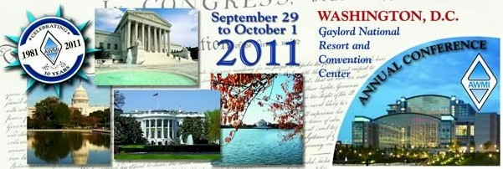](http://awmi.org/web/2007/11/international_events.aspx)](http://awmi.org/web/2007/11/international_events.aspx)**

**Raffle Prize**

**Lia SophiaJewlery**

**(Donated by Steiner Industrial)**

[](http://awmi.org/web/2007/11/international_events.aspx)

**Raffle Prize**

**ArcelorMittal Golf Items**

**(Donated by Arcelor)**

**$100 Visa Gift Card**

**(Donated by Northeast Region)**

[](http://awmi.org/web/2007/11/international_events.aspx)

**Raffle Prize**

**GPS**

**(Donated by Western Region)**

[](http://awmi.org/web/2007/11/international_events.aspx)

**Raffle Prize**

**iPad**

**(Donated by Detroit Chapter)**

[](http://awmi.org/web/2007/11/international_events.aspx)

**Raffle Prize**

**Coach Purse**

**(Donated by Cleveland Chapter)**

[](http://awmi.org/web/2007/11/international_events.aspx)

**Raffle Prize**

**Lia Sophia Jewelry**

**(Donated by Steiner Industrial)**

**Coach Purse**

**(Donated by Cleveland Chapter)**

[](http://awmi.org/web/2007/11/international_events.aspx)

**Lia Sophia Jewelry**

**(Donated by Steiner Industrial)**

**GPS**

**(Donated by Western Region)**